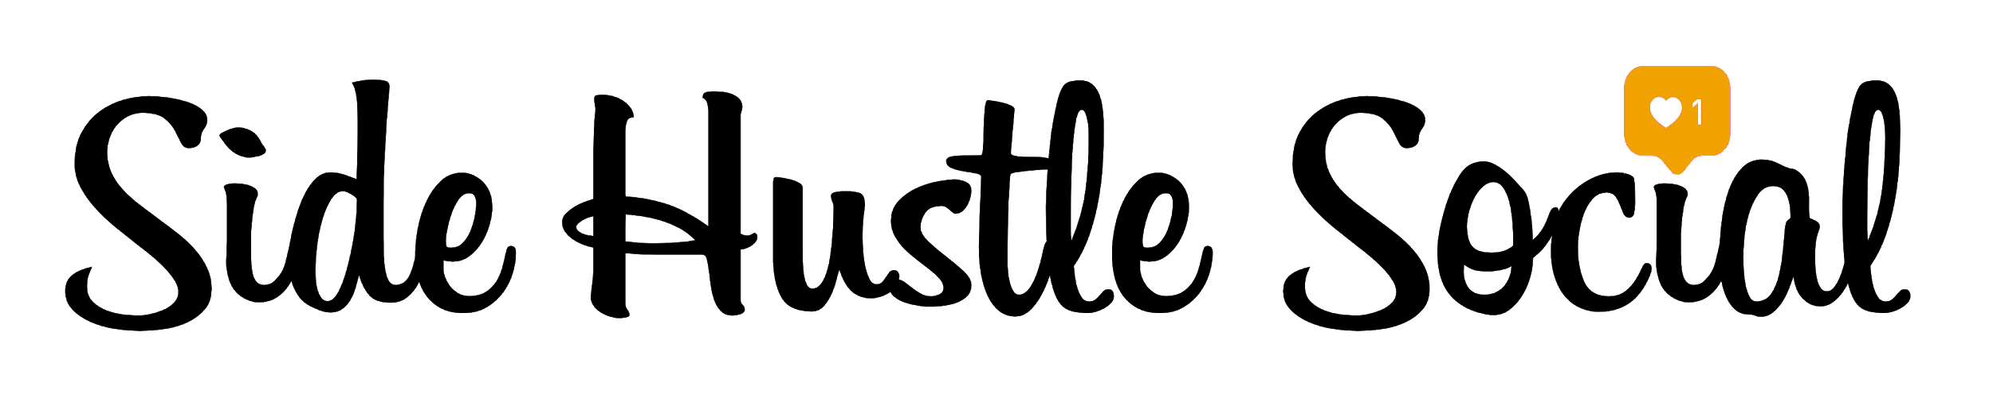

Influencer Agreement

Valid 12/2018-1/2019

This contract is an addendum to any existing influencer contract you may already have with Side Hustle Social.

- As a Partner,
  - You will Receive:
    - Revenue Share of 30%
    - Discount Code of $50
    - Free access to course
    - 4 Free Course Vouchers
  - You will Deliver
    - 6 total instagram story slides using given talking points
    - Provide Welcome page video for Registration page

Side Hustle Social will require all influencers to:

- Share 3 instagram story slides to per month with give talking points
- Allow Side Hustle to repurpose content for marketing and promotional purposes
- Give SIde Hustle white-listing permission to run advertisements from your social accounts*
- Avoid mentioning competitor brands Lewis Howes and Brandon Brouchard
- Adhere to FTC compliance guidelines outlined below

*This will not be an actual post on your page, only an ad that we put money behind using your images and captions. It will run on Facebook and Instagram.

Side Hustle Social will pay affiliate revenue via:

- Teachables built in affiliate system
- Can be paid through Paypal or Stripe

Important FTC Guidelines:

Because the FDA and FTC have strict guidelines about compliant advertising for dietary supplements, there are a few guidelines that you must follow in order to protect both our company and you as an influencer. These are legal guidelines, not created by Side Hustle Social, but set in place by governmental bodies, so they must be adhered to strictly.

- In any post you share about a product we send you free of charge, you must include a disclaimer making it clear that you received the product for free. Something like, “The Side Hustle Social team wanted me to try this…” would be great! It is important fully disclose that you are a brand ambassador who received products in exchange for your honest review in each post. This disclaimer must appear near the beginning of all posts about any products we provide to you free of charge.
- If there was any monetary compensation for a particular post, include #ad at the beginning of your post. FTC guidelines indicate that this disclaimer should be above the “See More…” button on Instagram.
- While we are interested in your honest feedback on products, we must ask that you refrain from making any unsupported claims on guaranteeing people will pay their bills with Social Media. While the product and results have been extremely strong, not everyone will follow the system laid out in the course

We reserve the right to request removal of any posts that make unsubstantiated claims and/or claims that may put our company at risk.

Sticking to topics such as your experience as an influencer, what type of content you make, and how much you enjoy your experience on social media is great!

This agreement can be cancelled upon 30 days written notice by either party for any reason.

I agree to the terms above.

Signature________________________________________________________________________

Name (Print)_____________________________________________________________________

Address_________________________________________________________________________

